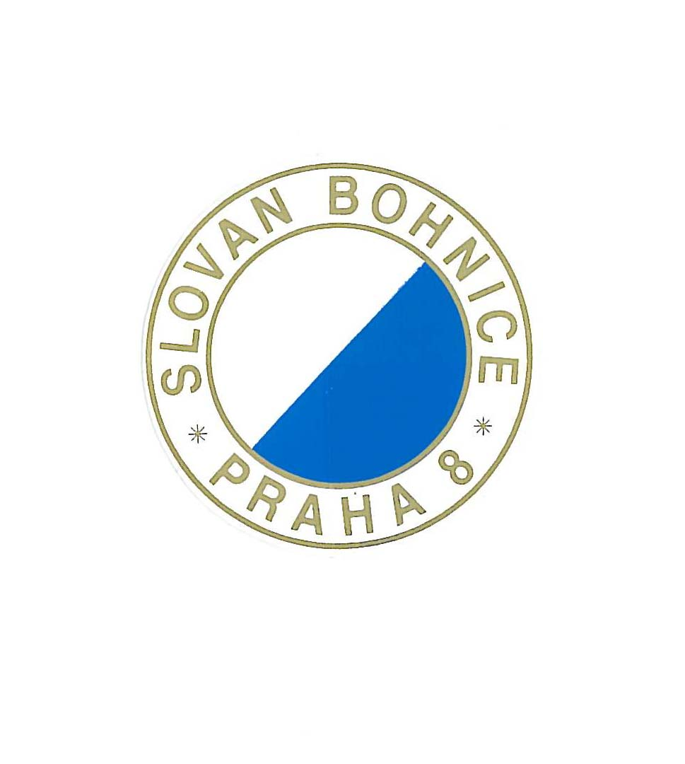
PRAGUE BMX CUP 2011 – 30.4.2011
and
International race – 1.5.2011

Organize: TJ Slovan Bohnice – club BMX and SCM

Location: track BMX, Lindavská Steet, Praha 8-Bohnice
GPS: 50°7'44.722"N, 14°25'57.036"E

Category: B 6,7/8,9/10,11/12,13/14,15/16, M17/24,
M25/29, M30+, Cr-18, Cr19/29,Cr30/39, Cr40+
Elite Men, Elite Women, Junior Men, Junior
Women

PROGRAMME:
FRIDAY April 29th

04.00 PM - 08.00 PM Official gate practice, for all Riders.
04.00 PM – 08.00 PM Registration

SATURDAY April 30th

08.00 AM – 09.00 AM Gate practice for challenge category
Cr18 and under,19/29, 30/39,40 and over Boys: 6 and under,7/8,9/10,11/12,13/14,
09.30 AM 3 motos
quarter, semi and finale
Awards ceremony
01.00 PM – 01.30 PM gate practice for challenge B15/16,M17/24
M25/29, M30+
01.30 PM – 02.00 PM gate practice JW,EW,JM,EM
02.15 PM 3 motos
quarter, semi and finale
Awards ceremony

SUNDAY May 1st

08.00 AM – 09.00 AM Gate practice for challenge category
Cr18 and under,19/29, 30/39,40 and over Boys: 6 and under,7/8,9/10,11/12,13/14,
09.30 AM 3 motos
quarter, semi and finale
Awards ceremony

01.00 PM – 01.30 PM gate practice for challenge B15/16,M17/24
M25/29, M30+
01.30 PM – 02.00 PM gate practice JW,EW,JM,EM
02.15 PM 3 motos
quarter, semi and finale
Awards ceremony

Each rider must have own number plate with the right international numbers. (cat.6-8 with your national numbers.)

REGISTRATION BEFORE APRIL 16

Must be send to:

e-mail bmxbohnice@seznam.cz

The foreign countries will pay entries in Czech crone at registration control

ALL REGISTRATIONS MUST BE PAID HEAD OF DELEGATION

Entry fees:

Cruisers, Boys, Girls - 200,-CZK
JM, JW - 300,-CZK
EM, EW - 500,-CZK

BMX Camping: near by the track - open from 29th April 2011 13pm to 2nd May 2011 10am
To disposal showers, toilets, without electricity
Capacity is limited - application form please send to e-mail: bmxbohnice@seznam.cz
Cost : caravan, Mobil home – 60,-€, tent – 35,-€ for all days

Hotels: please contact travel agency SKITUR, Matěchova 18, 140 00 Praha 4 – www.skitur.cz e-mail: info@skitur.cz

Price many: TOTAL – 35.560,-CZK

ELITE MEN 1ST - 7000,-CZK ELITE WOMEN 1ST - 3000,-CZK
2nd - 5000,-CZK 2nd - 2000,-CZK
3rd - 2400,-CZK 3rd - 1000,-CZK
4th - 1500,-CZK 4th - 600,-CZK
5th - 1200,-CZK 5th - 600,-CZK
6th - 1000,-CZK 6th - 500,-CZK
7th - 800,-CZK 7th - 500,-CZK
8th - 500,-CZK 8th - 400,-CZK

JUNIOR MEN 1ST - 2000,-CZK JUNIOR WOMEN 1st - 1000,-CZK
2nd - 1200,-CZK 2nd - 700,-CZK
3rd - 800,-CZK 3rd - 500,-CZK
4th - 600,-CZK 4th - 400,-CZK
5th - 500,-CZK 5th - 300,-CZK
6th - 400,-CZK 6th - 200,-CZK
7th - 300,-CZK 7th - 160,-CZK
8th - 300,-CZK 8th - 140,-CZK

