

UEC CONVENTION

ORLEANS : FEBRUARY 4th 2012

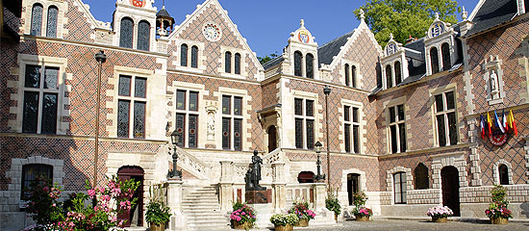
MEETING PLACE :

HOTEL GROSLOT
PLACE DE L’ETAPE
450000 ORLEANS

This is the name of the old city Hall. It is close
to Cathedral Sainte Croix and in front of the new
City Hall.

HOW TO GO TO ORLEANS :

- Motorway : A10 > Paris - Orléans – Bordeaux
- Railway : SNCF : 1 h from Paris (Gare d’Austerlitz) : there are 2 stations : Fleury les Aubrais (north of the city) and the city centre station : shuttles between both stations as well as tram available. Better chose arrival to city centre station (very close from the hotel)
- Airlines : shuttles and/or taxi, RER, between the 2 Paris airports : Roissy Charles de Gaulle and Orly and the railway station Gare d’Austerlitz.

TIMING OF THE DAY :

- 9.00 Start of meeting
- 12.45 Live Hotel Groslot to lunch place
- 13.00 Lunch
- 14.30 Visit of exhibition hall and surroundings
- 16.00 End of meeting day

SUGGESTED HOTEL :

If you arrive in Orleans on Friday evening we suggest following hotel

HOTEL BEST WESTERN – HOTEL D’ARC
37 Ter, Rue de la Republique,
45000 Orleans
Tel: +33 2 38531094
Fax: +33 2 38 81 77 47
mailto: hotel.darc@wanadoo.fr

www.hotel-arc-orleans.com

Special rate for BMX. Just mention you come for the BMX Convention.

The hotel is near to railway station and 500 m from the convention place. Shuttles will be organized between hotel and Hotel Groslot

For those who have an early plane in Paris on Sunday morning, we strongly advise you to go back to Paris on Saturday evening.

So as to facilitate the organization of this meeting day we kindly ask you to send back the enclosed entry form by January 15th at the latest.

to Ilija Kesic : uec.bmx.comm@bluewin.ch
with copy to Rene Nicolas : bmx.europe@orange.fr

COUNTRY NAME : ………………………………………………………………………..

FEDERATION :………………………………………………………………………………

Will participate to the UEC CONVENTION on February 4th 2012 in Orleans
Will not participate to the UEC CONVENTION on February 4th 2012 in Orleans

We ask you to limit your participation to one national delegate and 2 delegates per organizing body (for countries who will hold a UEC European event)

NAME OF PARTICIPANT : | FUNCTION :  MOBILE NUMBER :

NAME OF PARTICIPANT | FUNCTION :  MOBILE NUMBER :

NAME OF PARTICIPANT | FUNCTION :  MOBILE NUMBER :

Any other comments :

