Invitation to
“BMX Grand Prix Latvia” Round 2 at Madona
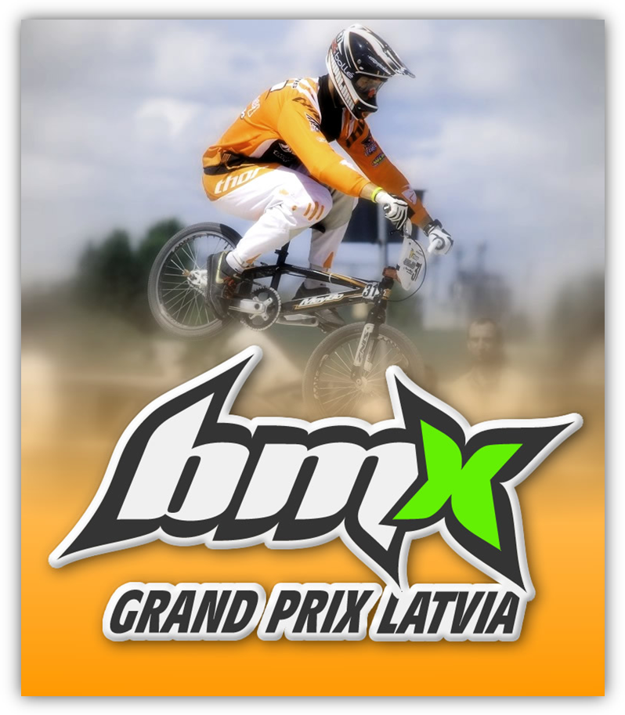
Latvian Cycling Federation has the proud to invite on UCI 5th category International 6 round Tournament
“BMX Grand Prix Latvia”. Rounds ARE held AT different Places of LATVIA.
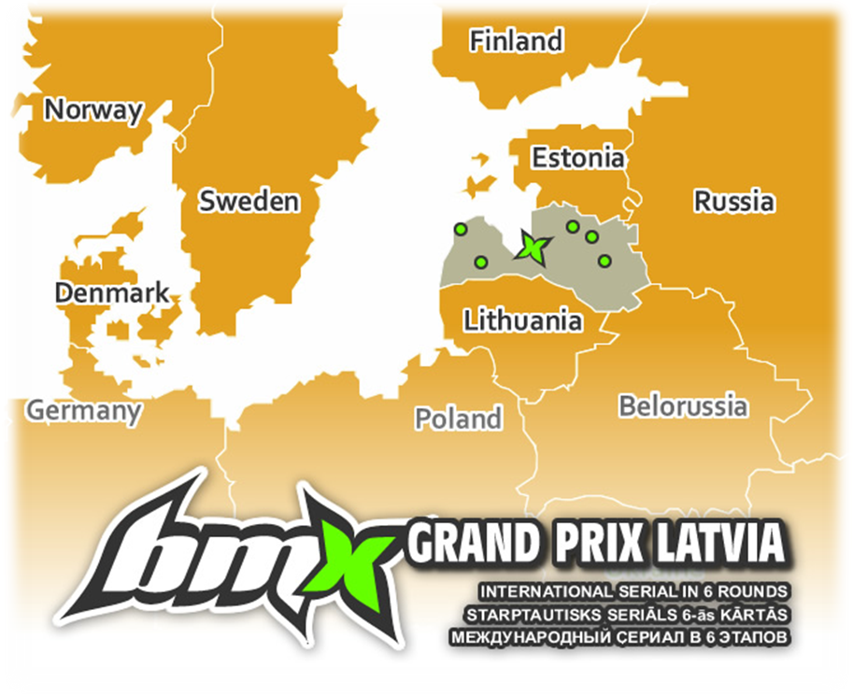

Calendar
„BMX Grand Prix Latvia” rounds will be held on following dates and places:
- Round 1 – May 15, Ventspils;
- Round 2 – Juny 12, Madona district;
- Round 3 – July 17, Burtnieku district, near Valmiera;
- Round 4 – August 7, - Saldus;
- Round 5 – August 28, Smiltenes district, Silva;
- Round 6 – September 25, Riga, Mezaparks.
There is an option to apply for all rounds. All rounds are equal and will be counted in overall ranking.
Locations map of all rounds observable here: http://maps.google.com/maps/ms?ie=UTF8&hl=lv&msa=0&msid=215887759087536744049.00049ca8014ee21cbc8d5&z=8

General Information
Contacts: Latvian Cycling Federation
Grostonas 6b, Riga, LV-1013, Latvia
For registration and questions: e-mail: entry@bmxgrandprix.com
Iveta Gutmane (General Secretary): Tel. (+371)29288517
e-mail: iveta@lrf.lv
Miks Pukitis (BMX Coordinator): Tel. (+371)29118558
e-mail: bmx.menedzeris@inbox.lv
Janis Grinvalds (Public Relations): Tel. (+371)26499454
e-mail: prese@lrf.lv
WEB site: www.bmxgrandprix.com
Date of event: 12 juny, 2011
Place of event: Sport Complex “Smeceres sils”
Madona district, LV-4824
Registration deadline: 4 Juny, 2011

Clases
Challange clases Championship clases
Year of Birth | Class
2006-2005 | B5/6
2004 | B7
2003 | B8
2002 | B9
2001 | B10
2000 | B11
1999 | B12
1998 | B13
1997 | B14
1996 | B15
1995 | B16
1994-older | M17+
1998-older | Cruiser13+
2007-2001 | G5/10
2000-1997 | G11/14
1996-older | G15+

Rules
Year of Birth | Class
1994-1993 | Junior Men
1992-older | Elite Men
Competition goes under UCI Rules.

Registration
Registrations with payment or registration fees can be sent trough national BMX office. But there’s possibility to enter for race using interactive form available here:
http://www.bmxgrandprix.com/about-competition/events/round-2-madona/entry-to-round-2---madona-12-06-2011
For individual cases, questions send e-mail to entry@bmxgrandprix.com
The deadlines of registration for each round:
Round | Place | Event date | Deadline
1 | Ventspils (“Piedzīvojumu parks”) | May 15 | April 30
2 | Madona (“Smeceres sils”) | Juny 12 | June 4
3 | Valmiera (“Avoti”) | July 17 | July 9
4 | Saldus | August 7 | July 30
5 | Smiltene (Silva) | August 28 | August 20
6 | Riga (Mezaparks) | September 25 | September 17
Registration Fee for round(event)
Class | LVL
Challenge classes | LVL 7
Elite Men | LVL 30
Junior Men | LVL 20

Prizes

Prizes by round
All finalists of each class will be awarded at each round. Elite Men and Junior men finalists will be awarded with following money prizes (LVL):
Class | 1 | 2 | 3 | 4 | 5 | 6 | 7 | 8
EM | 200 | 100 | 55 | 45 | 40 | 35 | 30 | 25
JM | 100 | 55 | 30 | 25 | 20 | 15 | 10 | 10

Prizes by overall
After round 6 in Riga TOP3 Riders of each class will be awarded with “BMX Grand Prix Latvia” Cups.
To win Latvians in Latvia – It’s a Great Achievement!

Time shedule
*Time may change depending on the number of participants and other possible difficulties.
Sunday  12 Juny | 9:30 – 11:00 | Registration / Entry
Sunday  12 Juny | 10:00 – 10:30 | Track Practice. Boys 5-12/Girls 5-14
Sunday  12 Juny | 10:30 – 11:00 | Track Practice. 13 and Older
Sunday  12 Juny | 11:00 – 11:30 | Gate practice. Boys 5-12/Girls 5-14
Sunday  12 Juny | 11:30 – 11:55 | Gate Practice. 13 and Older
Sunday  12 Juny | 11:30 | Team manager Meeting
Sunday  12 Juny | 12:00 | Motos 1-3
Sunday  12 Juny | *14:00 | Semifinals, Finals
Sunday  12 Juny | *15:00 | Awards Ceremony

Races day before
In same weekend of each round of “BMX GP Latvia” on Saturdays will be possibilities to participate in races open for international riders. Entry will be provided before event.
 | Date | Title | Place | Registration
Bef. Round 1 | May 14 | Season Opening | Ventspils | 10:30-12:30
Bef. Round 2 | Juny 11 | Federation Cup | Madona | 10:30-12:30
Bef. Round 3 | July 16 | Federation President Cup | Valmiera | 10:30-12:30
Bef. Round 4 | August 6 | Lemberg’s Cup | Ventspils | 10:30-12:30
Bef. Round 5 | August 27 | Baltic Cup, Round 3 | Tartu, EST | 10:30-12:30
Bef. Round 6 | Sept. 24 | Riga Cup | Riga | 10:30-12:30

National Team Pitlane
The National Team Pitlane will be next to BMX Track. At a cost of LVL 30,00 for the weekend, it’s possible to put 1 standard push-up tent (3x3m). The National Team Pitlane will be open from 12.00 on Friday the 13th May and is available for all teams.
Payments can also be done by the Team Manager at secretary/registration center of event.

National Team manager and Asistants
From UCI Rule Book: Each national federation which registers riders must appoint a single national team manager to represent the interests of all of its riders at the international BMX race. In addition to this national team manager, a number of assistant team managers shall be allowed according to the following scale:
Number of attending riders | Number of permitted assistants
1 - 100 | 3
101 and over | 4
Host nation | 5
A national team manager or his nominated assistant is accredited with the right to enter a restricted zone, as granted by the race director, in order to perform his duties.

Location
Location of Madona and road (Thanks to Google Map!)
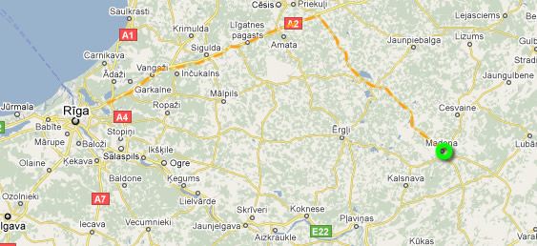
Track Location and Madona. Track located at sport complex “Smeceres sils” near the town. On beltway around Madona (P37) there will be sign showing Direction to complex.
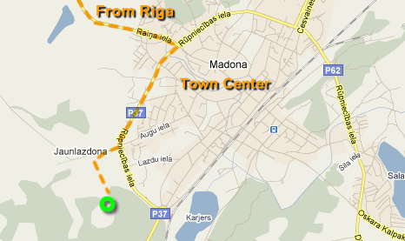
Coordinates for navigators: 56.840118, 26.191953

Route
- International Airport: Riga International Airport(RIX) with regular flights.
Distance to venue: 180km, 2h 35min (Map)
Many well known Car Rent companies available at airport.
- Buses from Riga to Madona Bus station depart almost every hour. Buss station is close to Riga Railroad station.
Info about traffic available at www.1188.lv . 1188 is also major Information centre by phone.

Accommodation possibilities
Tent places behind track for free.
Near track there is grass field for tents and camping available.
Other options: There are many accommodation possibilities inside or around Madona. Check out Official Madona Tourism page and its page of accommodation! http://www.madona.lv/turisms/en/?s=1271012807&ln=en
If you have some questions or difficulties to find best deal and place, contact
Madona Tourism information centre:
Address: Saieta laukums 1, Madona, Madonas novads, LV – 4801
Phone: +371 64860573, 29130437
Web: www.madona.lv; E-mail: tic@madona.lv
Working hours: Mo, Tu, We, Thu, Fr: 8.00-17.00
Sat, Sun: closed

Parking
Parking for participants, managers, officials, representatives provided next to track for free.

Food
There will be outdoor catering tent behind BMX-track. But for other options check public catering page at official site: http://www.madona.lv/turisms/en/?s=1273605689&ln=en

Paramedics
A paramedics team will be present at practices and racing.

Responsibility
Organizer and the city of Ventspils do not bear any responsibility regarding thefts or damages happening on the site, during the race, on the parking lots, on the campground or the „Piedzīvojumu parks” site.

More information on
www.bmxgrandprix.com

