INVITATION
ALPE ADRIAN CHAMPIONSHIP ROUND 7-8.
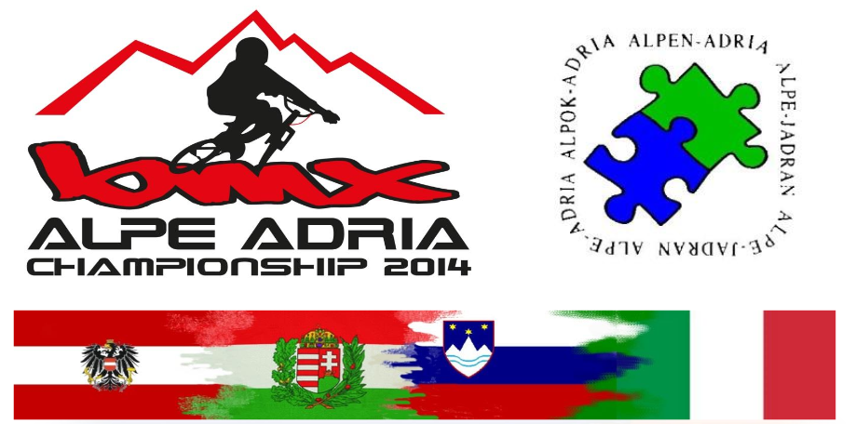
HUNGARIAN BMX-CROSS INDIVIDUAL NATIONAL CHAMPIONSHIP - ROUND 5-6.
COMPETITION OF OLYMPIC HOPES

- Welcome
The GYSEV Sopron BMX Team will organize on this year the Hungarian National Championship, the Alpe Adria Championship and the Competition of Olympic Hopes.
This is the first time for BMX sport that the Competition of Olympic Hopes is organized for Visegrad countries (Czech Republic, Slovakia, Poland and Hungary).
We invite everyone with great love for a very good race.
- Local Information
Location: BMX Track of Sopron is located in northwest of Sopron, close to the Austrian border.
Address: end of IV. Laszlo Kiraly street Sopron, Hungary 9400.
GPRS coordinate: N47.695859° E16.570503° or N47° 41.752' E16° 34.230'
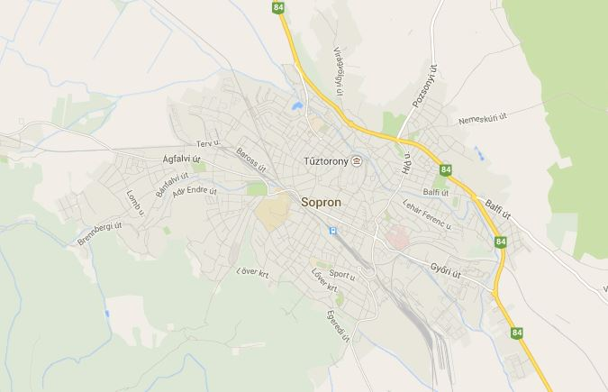
Wien
Győr
BMX TRACK
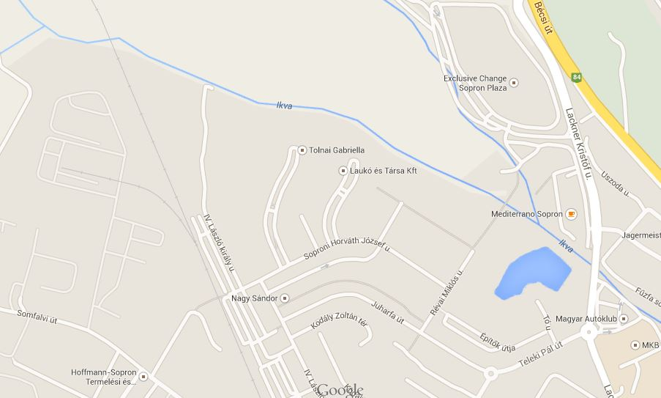
Wien
BMX TRACK
- General Information
Event Organiser: GYSEV Sopron BMX SE
Chief Judge: Ferenc Borbely (Hungarian Cycling Federation)
Website: www.bmxhungary.hu
Venue address: end of IV. Laszlo Kiraly street Sopron, Hungary 9400
Event Date: 02 & 03 August 2014
- Classes and Registration.

Classes | Entry Fee (Euro) | Notes
Amateur | 5 € | After the registration we will make more groups if the numbers of riders more than 5 and the age of riders are various.
Boys under 8 | 8 €
Boys 9-10 | 8 €
Boys 11-12 | 8 €
Boys 13-14 | 8 €
Cruiser and MTB | 8 € | Rider who is younger than 25 years old
Masters | 8 € | 25 years old and older (also for 20” and 24” and 26”)
Boys 15-16 | 10 €
Women 17+ (Elite and Junior) | 10 € | After the registration we will make this groups if the numbers of riders more than 5.
Men 17+ (Elite and Junior) | 10 €
The Cruiser MTB and Masters will compete together if in the Masters category the riders number less than 5.
The entry fee is valid for pre-registration if you register at the race you should pay 5 € more! The pre-registration deadline: 29.07.2014 (midnight)
The pre-registration is helping us to calculate with the groups’ number. Please do not forget it.

- Prizes and awards
Trophies for first three place in class of Amateur, Boys under 8; Boys 9-10, Boys 11-12, Boys 13-14, Cruiser and MTB, and Masters
Prize money in class of Boys 15-16, Women 17+ and Men 17+
 | Boys 15-16 | Men 17+
1st | 18 € | 35 €
2nd | 15 € | 30 €
3rd | 12 € | 25 €
4th | 10 € | 20 €
5th | 8 € | 18 €
6th | 7 € | 16 €
7th | 6 € | 12€
8th | 5 € | 10 €
- Rules
You ride at your own risk and assume all responsibility for yourself and your equipment. The organizers are not responsible for any accidents that occurred at the event.
The boys and girls are race together.
The riders of category Men 17+ and Boys 15-16, Masters and Cruiser/MTB should use the Pro Section.
The UCI and Alpe Adrian Championship rules are in place during the race.
AGE OF GROUPS
Boys under 8 | - 2008
Boys 9-10 | 2004 - 2005
Boys 11-12 | 2002 - 2003
Boys 13-14 | 2000 - 2001
Boys 15-16 | 1998 - 1999
Cruiser and MTB | - 1990
Masters | before 1989
Women 17+ | before 1997
Men 17+ | before 1997
RIDER EQUIPMENT
Short pants are allowed for all riders provided they are used together with knee and shin protection with a rigid surface that extends from the knee protection to fully cover the shin until just above the ankle. The Hungarian BMX Federation recommends for safety reasons the use of long Pants.
Riders aged 13 and older are allowed to use clip pedals.

- Schedule
DATES: 02-03. August 2014.
RESGISTRATION: 02.08.2014. Saturday 13.00 - 14.00
03.08.2014. Sunday 09.00 – 10.00
TRAINING: 01.08.2014. Friday 17.00 – 20.00
without ambulance
02.08.2014. Saturday 14.00 - 15.00 (warm up)
with ambulance
03.08.2014. Sunday 09.00 - 10.00 (warm up)
with ambulance
02.08.2014. Saturday Start gate training
15.00 - 15.20 Men 17+, Boys 15-16, Masters and Cruiser, MTB
15.20 - 15.40 Boys/Girls –8; 9-10; 11-12, 13-14, Amateur and Women 17+
03.08.2014. Sunday Start gate training
10.00 - 10.20 Men 17+, Boys 15-16, Masters and Cruiser, MTB
10.20 - 10.40 Boys/Girls –8; 9-10; 11-12, 13-14, Amateur and Women 17+

RACE START: 02.08.2014. Saturday 16.00
03.08.2014. Sunday 11.00

- Car Parks
The car park for the event will be located outside the fence and in the campsite area for camper (You can see on the map with blue colour).
- Team Area and Stores
If you are interested in trading at the event, please email kpbmx@t-online.hu.
If you have tent for team you can placed it in red area, behind the railing, and on embankment between the first and second turns.
- Camping
Camping is located next to the track inside the fence and if it is full, near the park (black areas). The camping is free.
We can provide electricity and toilette. We are also providing bathing facilities at the nearby school.
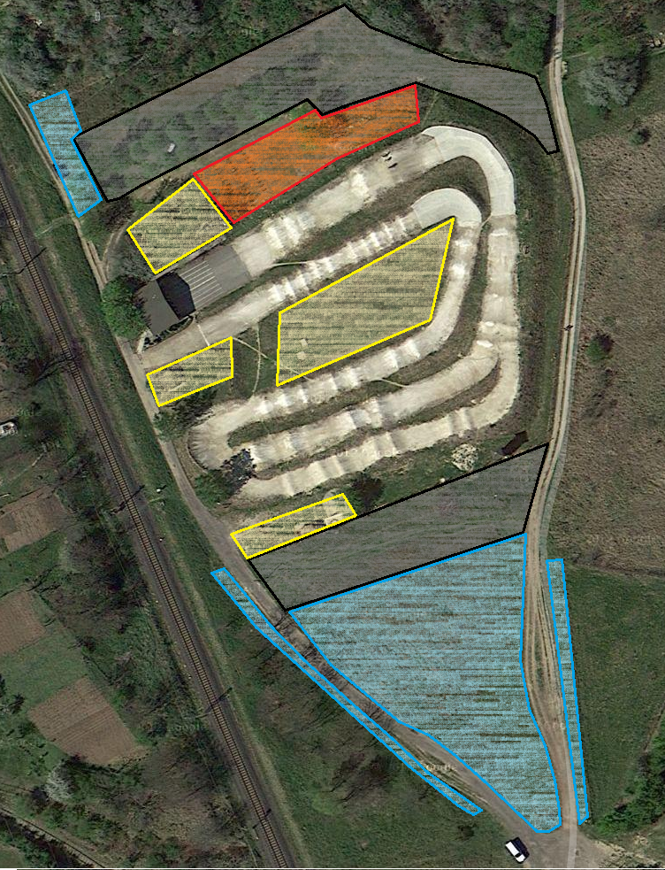
Area for riders
Camping
Parking
For organiser

