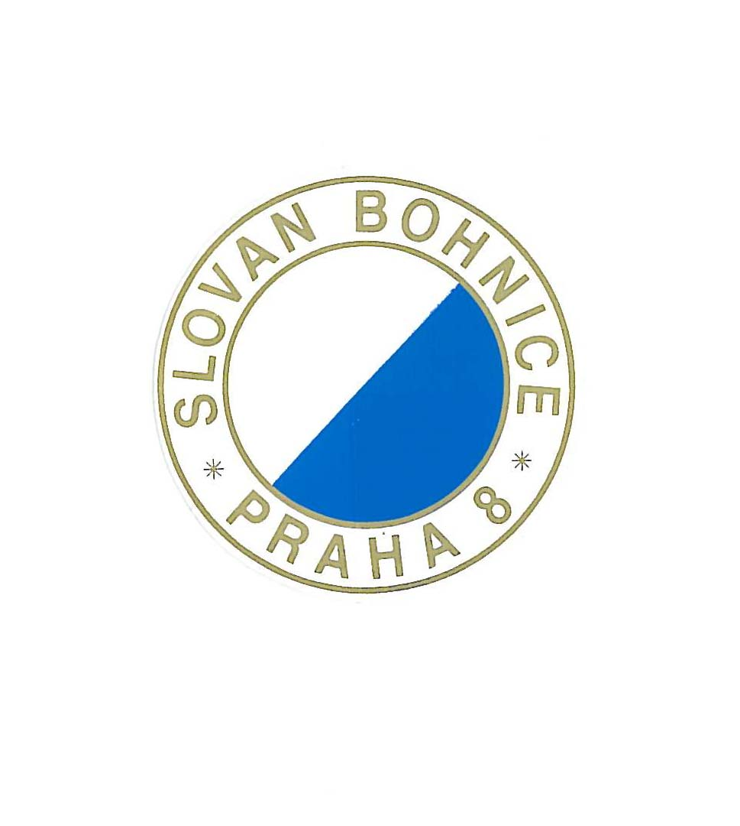

INVITATION

Saturday 7th and Sunday 8th of May 2011

European BMX Championship rounds 5 & 6

Organisation: TJ Slovan Bohnice – club BMX

Location: BMX track – Lindavská street – GPS: 50°7'44.722"N, 14°25'57.036"E

Classes: B 9/10, 11/12, 13/14, 15/16, M17/24, M25/29, M30+
G 9/10, 11/12, 13/14, 15/16, W 17+
Cr.13/14, 15/16, 17/24, 25/29, 30/39, 40/44, 45+
JW, JM, EW, EM

Entry: Only via national federation

Entry fee: Challenge classes: € 27, – per round
Junior: € 35, - per round
Elite: € 57. - per round

Entrance: free entrance

Blocs: Bloc 1: challenge classes B & G 9/12, all cruiser classes 13 year and older.
Bloc 2: challenge classes B & G 13/14, 15/16, M 17-24, M 25/30, M 30+, W 17+.
Championship class: JW, JM, EW, EM

BMX Camping: near by the track - open from 6th May 2011 10am to 9th May 2011 2pm
Showers and toilets are on site, camp is without electricity
Capacity is limited - please send application form to e-mail: bmxbohnice@seznam.cz
Price : Caravan, Mobil home – 60,-€, Tent – 35,-€ for all days

Hotels: please contact travel agency SKITUR, Matěchova 18, 140 00 Praha 4 – www.skitur.cz e-mail: info@skitur.cz

Time Schedule: Friday May 6th 2011:

- 16.30 – 18.00 gate practice for all 20” challenge classes 9 years and older.
- 18.00 – 18.15 gate practice for all cruiser classes 13 year and older
- 18.15 – 19.00 gate practice for Junior men
- 19.00 – 19.30 gate practice for Junior and Elite women.
- 19.30 – 20.15 gate practice for Elite men
- 16.30 - 20.00 registration - team managers only

Saturday May 7th 2011:

- 08.00 – 09.00 Registration control by UEC Administration
- 09.00 Team managers meeting.
- 08.30 – 09.15 gate practice bloc 1.
- 09.30 moto 1 – 3 Bloc 1

- 11.30 – 12.15 gate practice bloc 2.
- 12.15 moto 1 3 Bloc 2
1/8 finals - Bloc 1 & 2
¼ finals - Bloc 1 & 2
½ finals - Bloc 1 & 2
finals - Bloc 1 & 2

Awards ceremony for Challenger

- 14.30 – 15.15 Splited – gate practice for JW, JM, EW, EM
- 15.15 Moto 1 – 3 championship classes.
Finals championship class

Awards ceremony championship classes

Sunday May 8th 2011 :

- 08.15 Team managers meeting
- 08.00 – 8.30 gate practice bloc 1.
- 08.45 moto 1 -3 Bloc 1
- 10.15 – 10.35 gate practice Bloc 2.
- 10.45 moto 1 – 3 Bloc 2
- 1/8 finals - Bloc 1 & 2
¼ finals - Bloc 1 & 2
½ finals - Bloc 1 & 2
finals - Bloc 1 & 2

Awards ceremony for Challenger

- 13.00 – 13.30 gate practice for JW,JM,EW,EM
- 13.30 Moto 1 – 3 Championship classes 1/8 finals, ¼ finals, ½ finals, finals

Awards ceremony championship classes.

Changes reserved

